Metropolitan Public Gardens Association
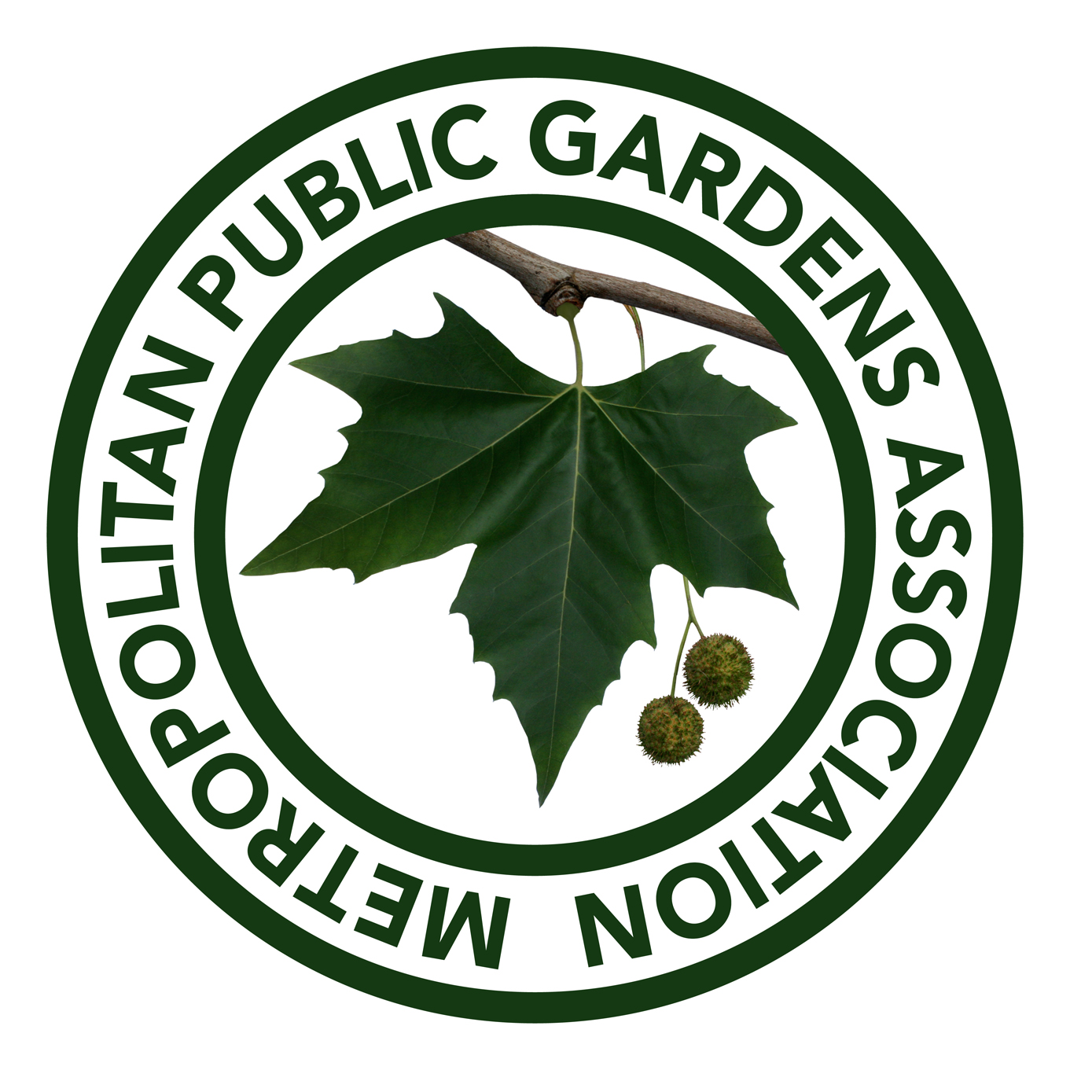

in association with
Taylors Bulbs of Holbeach

BULBS FOR LONDON 2022

ORDER NUMBER | leave blank /2022 leave blank  Acc No
Name of Park/Site
Address | Post Code
London Borough
Contact Person | Position:
Organisation

Type of Organisation
Tel / Email address  ^{Twitter}  DELIVERY address/contact if different to above  IT IS ESSENTIAL THAT SOMEONE IS AVAILABLE AT THIS ADDRESS TO ACCEPT DELIVERY | Email: Mobile:  Twitter:
DELIVERY ADDRESS:

Email: Mobile:

Name of site and full description of where the bulbs will be planted
Signed |  | Date
Print Name

Lucky Dip around 400 bulbs of four or five varieties
The bulbs are supplied as a fixed package
and we cannot provide further details

The offer is site specific and all bulbs supplied must be planted at the nominated site.

For your application to be considered, please complete clearly all sections of the above form and email it to shirley@mpga.org.uk as soon as possible.

Successful applicants will be advised quickly, shortly after which the bulbs will be despatched, and should be planted before Christmas.

