*“Just Plant it” – The huge benefits (and difficulties) of growing hedges and scrub in London’s greenspaces – a why to and how to plant in Climate Change*

Here are the key numbers and sites we used in our hedge and scrub planting:

* **The Community Volunteers (“the TCV”) – I Dig Trees**

The TCV has been a fantastic organisation for our hedge and scrub planting. “Friends” organisations are so lucky that TCV are giving out free whips and trees and all you have to do is to put:

I Dig Trees

Into your search bar and click on

Claim your FREE trees now

and register to get a maximum of 950 trees. We got Pack 4 (which was then Hawthorn, Hazel, Grey Willow, Spindleberry, Dogwood and Dog Rose) but has now changed to take out Grey Willow and include Blackthorn. Please note that although Blackthorn (Sloe) is very pretty white blossom in the Spring, it is very invasive, so be slightly wary of it in a mixed hedge and particularly if used near paths. Blackthorn is more for “scrub” planting than “hedge” planting in London. In 2022, TCV also offer packs of entirely Hawthorn whips which we have seen are good for hedge use under light tree cover.

* **TCV Handbooks**

<https://www.conservationhandbooks.com/> These are excellent and thorough expert advice, helping with hedge choice, preparation, planting, aftercare and watering.

* **Hedges Direct**

We used Hedges Direct for our Gorse – [www.hedgesdirect.co.uk](http://www.hedgesdirect.co.uk) 01257 494 005 or [helpdesk@hedgesdirect.co.uk](mailto:helpdesk@hedgesdirect.co.uk). As we are volunteer organisations, Hedges Direct may give you a discount if you ask, particularly if your order is over a certain amount.

* **The Queen’s Green Canopy**

The Queen’s Green Canopy (QGC) is a unique tree planting initiative created to mark the Platinum Jubilee, whether planting a young sapling (a whip) or a large tree. You may also be able to get free whips from The Woodland Trust if you choose to make your hedge part of the QGC. However, we found TCV a very straightforward way of getting our plants and the TCV encouraged us to register our hedges and scrub as part of the QGC in any event. queensgreencanopy.org

* **Species we used**

We used Hawthorn, Hazel, Grey Willow, Spindleberry, Dog Wood and Dog Rose in our Hedge Plantings and the same in the Scrub Planting with the addition of Gorse, Purging Buckthorn, Alder Buckthorn and Holly.

What to aim for

As well as being a “Bonsai” type carbon capturer, for us, as LFGN members, a hedge should be seen as a wildlife superhighway to encourage pollinators and birds in and along, from one area of public space to another. The aim of the hedge should be to provide a safe haven and feast for its inhabitants. We could “join London up” as a green space if hedges were run along all the roads of London. The potential of the hedge is massive and underused in London, especially as the London councils own so many properties, which hedges could run through. Transport for London could be doing much more to use it for its anti-pollutant capacities. Whilst amazing, the downside of trees is that, if chosen incorrectly for their site, they can get too large (both canopy and root system) and can deprive areas of sunlight whereas hedges are a much more manageable option if an annual cut is done when the hedge is dormant.

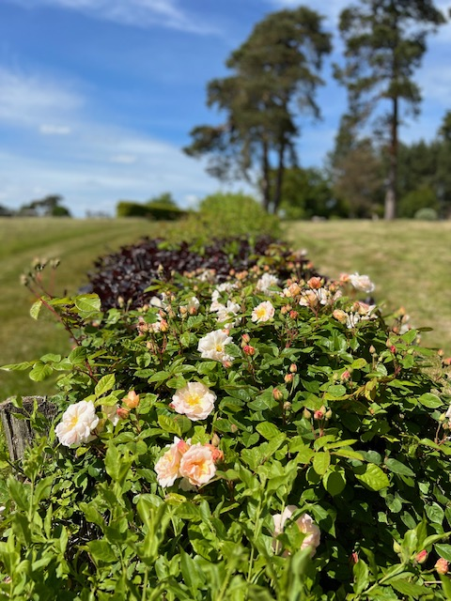There is no reason why every hedge we plant cannot be as beautiful as this hedge, planted 20 years ago and every green space custodian can use their artistry to create unique mixes of perfect plants for situations. Some of us will have to use wild and native plants in our hedges and scrub, like we had/have to do on Wandsworth Common, but others may have more flexibility in their choice of plants (as here, where Copper Beech is used to good effect, together with a more general climbing rose, alongside the natives (Dog Wood, Spindleberry, etc.).

A first year of experience, planting hedges in Climate Change conditions/“Project Mark”

Project Mark was a hedge and scrub planting project that was done at the beginning of this year (2022) by a group of the three entities running and managing Wandsworth Common, including the Friends Group (part of the LFGN). Each entity brought valuable contributions to the project as a whole - know-how, enthusiasm and most importantly, the Friends brought the volunteers into the project to get the plants “in”. We planted 5 areas of the Common, 4 parts as hedges (the longest of which was 231 metres) and one as scrub. We had no idea when we started this project that on 19th July this year, the UK would have its hottest day ever, during a period of extreme drought.

This is written in the anticipation that future years may be as difficult or more difficult to get young plants started and in the hope that as many may see that planting a hedge is entirely possible by a Friends group, even in these more challenging circumstances (and think of starting in The 2022/2023 Planting Season).

Hedges – General Considerations

* What grows well naturally in your area? (If you are considering scrub land, could it just be a matter of rewilding it with your addition of species that occur naturally?)
* Expense. TCV will provide free whips to volunteer groups planting on greenspaces.
* From an historical perspective, is there anything that could be included? (In our case, Gorse had been indigenous but had largely be eliminated and we felt we could use it again successfully).
* Do you need the best anti-pollutive choice if the chosen area is roadside? This could be a mix of TCV free whips, plus a structural element that would be anti-pollutive year round. The choices from TCV do not include evergreen options and evergreen whips will be expensive (we used Hedges Direct for our Gorse).
* Hedges function as anti-pollutants at ground level where the pollution is being emitted. Trees are good, but hedge level is where the exhaust fumes are.
* Check if there is any Holly in your chosen area, if it is blighted, you will not want to use expensive Holly as your anti-pollutive, evergreen choice.
* Are you planting in a formal area (for example, by railings) or extending informal scrub? If by railings you will probably want to plant a hedge, giving it space, (a half metre) railings side, to cut and tend to.
* On Wandsworth Common, we have to ensure that any plants we use are from Bio-Secure sources (good practice for LFGN) and have to be grown in the UK from UK seed and ideally locally sourced. The TCV whips were suggested for our use by the bio-diversity team at Enable (who run the greenspaces in our area) as being appropriate.
* What species could you be using to broaden the bio-diversity of your greenspace? Can you achieve a truly beautiful mixed hedge? Can you craft it to feed pollinators and birds year round with plants that will get through their first year in current conditions?
* The Planting Season. Whips should be planted between November and March. We planted during February. You can plant as early in November as the whips are lifted, as dormant, from the Nurseries (which due to Climate Change is later this year).

Gorse as a scrub choice

Gorse is a great sporadic flowering plant year round (providing some Winter food opportunities for pollinators) and has certain useful qualities for scrub. It is a native and is an excellent evergreen choice. It will be good in roadside scrub planting because no (human) preditors will want to be hiding in it. For us, it was good in our scrub planting because it was more visible than the other whips and quickly “marked” the areas it was in (we got 2L pot plants to start, not Gorse plug plants). The public can more easily see where the Gorse plants are and avoid them and this plus is more obvious as winter approaches. Obviously Gorse isn’t one for a shaded area, although for us, it has worked in full sun and part shade.

Hawthorn as a hedging or scrub choice

Hawthorn was used on the first hedge on Wandsworth Common that was planted by Enable with Friends and the Wandsworth Common Management Advisory Committee as volunteers. It was the prototype for all the other hedge planting that has been done here (before our combined projects). Hawthorn has proved to take off well and grow well in a mid shaded place with what must be high levels of pollution. Hedges Direct advise that Cotoneaster Franchetii is a good anti-pollutive choice for a mix, being evergreen, but being a Common and wanting bio-diversity we prefer to use the I Dig Tree Hedgerow mix and will eventually use Holly as the evergreen buffer. Maybe if the pollution is really bad, you could consider an “outer” hedge roadside, having a void, then use an inner mixed hedge park side.

The use of Holly

Despite getting Holly from the MOST reputable supplier, it had Black spot and Holly Blight and had to be removed (and the amount of plants used carefully counted in). The disease could have been on the plugs or caught from the existing Holly in situ – impossible to say. So, the other thing to consider when using Holly is “is there any Holly in the surrounding area” – the chances are that if in London there will be both Black Spot and Holly Blight in the Holly. If you are going to use Holly for its evergreen, anti-pollutive, year round quality, it is best to be introducing it into an area with no existing Holly plants (which is restrictive as it has so many good qualities as a hedging plant). If there is no existing Holly in the area, it has less chance of succumbing to blight.

Climate Change impact on species on Wandsworth Common

Hawthorn seems to be a sturdy choice for a young hedge and the Year 2 Hawthorn fared very well in this year’s drought, but we noticed that older Hawthorn on our Common really suffered in this year’s heat, so we wonder whether Hawthorn, when the hedge is much older and Climate Change has really kicked in, will suffer similarly. Just to note, Alder here also fared badly and the Elders had their leaves burnt up. Our Horse-chestnuts are very diseased and also had their leaves burnt up. (Blackthorn had very early sloes and Beech had dried up Beechnuts). Grey Willow was not a good choice for a Climate Change Summer and we lost most of ours despite trying to water our plants when we realised we were in drought conditions.

Safety Considerations

Our Bio-Diversity Officer, Mick Green, at Enable, made a document detailing the consideration of the planting using volunteers which he has very kindly allowed me to disseminate. The key issues for planting in London spaces were most notably needles, glass and fox faeces. Please do refer to this very useful document which also gives other important details about the practicalities of planting.

Amount of plants per metre of hedge

We had interesting discussions on how many whips to plant per metre of hedge. 10 had been planted on the first Wandsworth Common hedge, then 5 was adopted as best practice for our plantings. The amount of plants used per metre could end up being a consideration of how much percentage loss you find acceptable for your hedge and the amount of watering that is intended to take place. In perfect conditions 5 would be the optimum number (giving good growth space), but perhaps a larger amount should be planted to cope with the plants that don’t make it in the hotter conditions we are facing if minimal watering is envisaged.

Mick made a “Spacer” for easy spacing of our plants (Design Right Mick Green!), when we determined we were going to use 5 whips per metre.

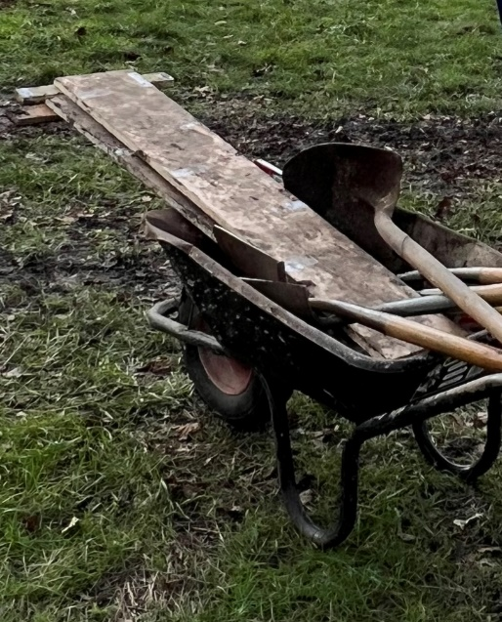

With regard to the scrub planting, Mick used a bio-degradable spray paint to mark out random shapes for the scrubs for a natural look and he put one stake in each area to warn the Public from walking on that area.

Arrival of the plants

It is so important to be in to take delivery of your whips. Below shows what could happen if the whips are not planted and are left for a while in a box. Be careful to give full delivery details and get the supplier to notify you of the exact arrival date.

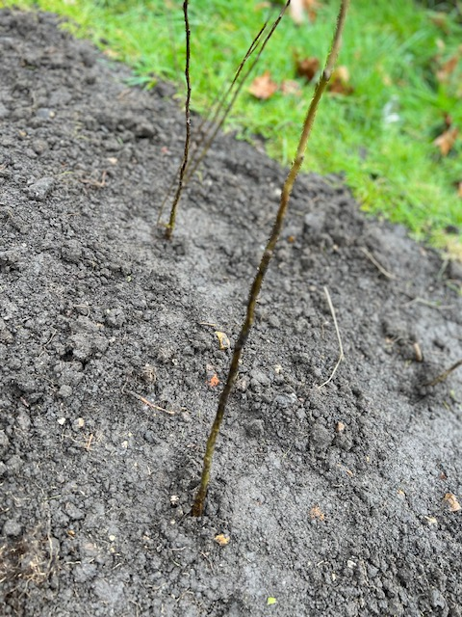

It is good to be ready with troughs of water prepared for the arrival of the whips.

Whips can be heeled in to the ground in a very basic way if there is to be a delay in planting them, as Mick did here.

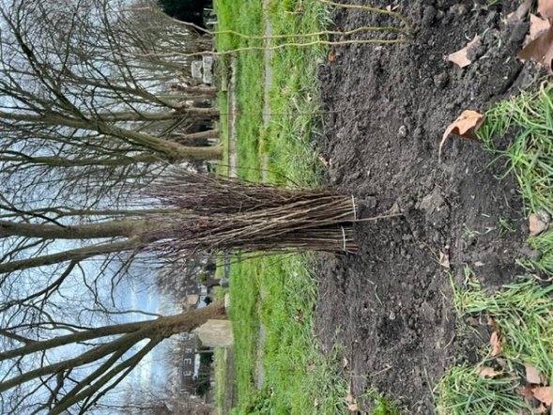

Methods of planting

We were lucky enough to have our hedge trench rotivated by Enable, but it is possible to still plant using the methods below with or without rotivation.

For the 4 large sections of hedging we did, we used the “slot’’ method of planting, with a spade (inserting in the ground and moving back and forth to create a slot, then gently placing the whip to one side of the slot and sort of folding the roots into the slot, then pressing both sides together with your foot, ensuring complete contact of both sides soil with the roots).

For the scrub planting we used the method of cutting out a square of turf, slicing it from the middle of one of the sides of the turf to the middle of the square, then turning the turf over. Then we dug a hole for the whip (where the turf had been extracted) and then placed the “turned over” “sliced bit” around the whip and trod it down. The grass is therefore underneath the ground and the dying grass releases nutrition for the young plant. The whip benefits from having no grass around it to “take off”. Care must be taken that you do not bury too much of the stem of the whip. The 2L Gorse pot plants were also planted using this method.

Mulching after planting

We mulched our hedges immediately and mulched our scrub plants later in the Spring/Summer when we found they are struggling with grasses growing up through them. An unexpected bonus of mulching the scrub plants was that it was hugely helpful in identifying where they were, particularly when we realised that the conditions were so dry, we felt compelled to water them. An unexpected result of mulching has been that we have grown some very interesting fungi.

Watering in Climate Changed conditions

This issue is of paramount importance for hedge planters in the first year. Our fall out of whips was (1) due to the use of Grey Willow which particularly struggled in this Summer’s dry conditions and (2) the lack of watering we, as volunteers, were able to do across the board. We just could not keep pace with ensuring the whole project was adequately watered to keep 100 per cent of the whips alive – when we faced the watering aspect it became very clear how ambitious we had been in trying to plant the four hedges and single scrub area.

Discussion needs to be had to determine what watering is realistic and the size of the annual project undertaken (number of whips planted). Each planting needs to factor in the watering of these tender young plants **every week in the event** of getting the extreme heat conditions we got this year where it happened incredibly quickly. On the 7th June the plants were relatively ok and on 24th June the plants were parched and shrivelled and dying. Looking back it would have been good to water the plants once a week through June and July to keep them healthy and better able to cope with the extreme conditions that were coming. Watering is an art and very time consuming – when and how much is a question of experience, learning from wilted leaves and signs of browning. This is where you need to be realistic as to the amount of planting you undertake and we have learnt from this.

The received wisdom from the experts is to accept a certain percentage of loss. This is ok if you are not using free whips or donated whips as we were. In our case you have the responsibility to the provider of the whips, or your benefactor to keep the whips alive and you will be loathe to loose the smallest percentage. Which brings us back to making good choices of type of whip in the first place and being realistic about your first year’s watering scheme before you start (can you keep an eye on your scheme on a weekly basis through June and July and be ready to water if you consider necessary?). Each plant needs enough water to entirely drench their root system, otherwise your plants will not effectively grown their tap roots which give them stability and get them to where the water in the ground will be last to be affected by the dry conditions. See the TCV Handbook guidance (website noted on the first page).

Although the hottest day in 2022 was 19th July, the dry period was beginning to show in the plants from 7th June.

Ad hoc – the unexpected issues we faced and what we learnt

Mulch must be left for three to four months before use so that any phytotoxic compounds are broken down and the mulch is safe for your young plants. We put fresh mulch on one of our hedges, in error and it had to be taken off again. The error was immediately recognised and remedied.

If you have a diseased plant, get rid of all that species quickly and dispose of them by burning or putting in the rubbish carefully sealed. The plant must not end up being composted or used as mulch.

We had Council Contractors strimming the plants in one of our hedges, by mistake. Interestingly we noticed that the strimmed hawthorn resprouted with strong growth that set it in good stead for the ensuing drought. Arguably, the strimmed Hawthorn fared better in the hot climate conditions this Summer than the unstrimmed Hawthorn. Cutting low early could be part of the process for young hedges in Climate Change conditions after they have “taken” (then they would resprout before their first July) but seeing the whips sprouting and starting to do well, would anyone be brave enough to do that?

Another issue that we faced were that poles and fencing were removed and discarded on the Common. These could be used violently.

The successes!

In our very first year, the Spindleberry and the Dog Rose flowered, which made the whole project worth it. The hedge plant that was first to flower was the Spindleberry, followed by Dog Rose.

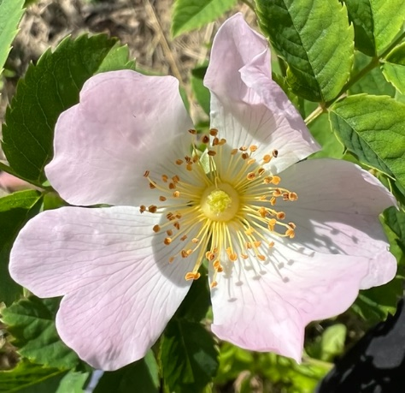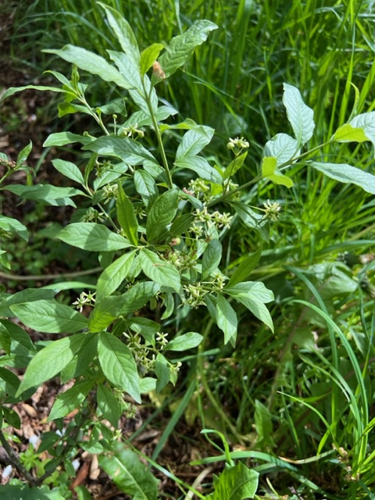

What we lost

We lost most of our Grey Willow which was in the TCV mix (and they have now taken out). This probably was not a good choice for the location anyway due to its water requirements. The Hazel looked like we had lost it in the Summer’s drought, but it has, for the most part, greened up or resprouted from ground level. Due to the regrowth which is hanging on tenaciously, we now hope we don’t loose the plants to frost! The Hawthorn by and large has done well (but see note re older plants) and Spindleberry and Dog Rose have fared very well and we have only lost a few of them in The Scrub area.

The 2022/23 Planting Season

This year we learnt a lot that we can implement in the new planting season. Enable, Friends and the MAC are once again joining together to plant trees and scrub but in one new location this time. The existing plantings will be redone when gaps occur and in the case of The Scrub Planting, we will augment the planting with a number of new plants. At Mick’s suggestion, we put in Alder Buckthorn and Purging Buckthorn into The Scrub Planting (2021/2022) and more of these species will be added this year.

The Great Join Up

Council properties may well benefit from the proliferation of hedges and would be a very good way of carbon capturing in them without the extensive use of light eliminating trees (considering here that a balance of sunlight and shade is good for mental well-being and mixed bio-diversity). Wouldn’t it be amazing if we could join London up with these perfect carbon capturing biohighways, carbon neutralising in situ?

Elizabeth Jeveons - November 2022

With thanks to Mick Green and Annabel Osborn at Enable for their extensive knowledge and guidance on our projects, to Chris Metcalfe, Chairman of the Wandsworth Common Management Advisory Committee (“the MAC”) for leading the MAC in these planting iniatives and to Julia Bott and Richard Fox, Joint Chairs of the Wandsworth Common Friends for providing structure to the project and to all the volunteers they sourced, without whom these plantings would not have been possible.

Key Dates - 2022

I February – Contractors rotivate 231 metres of ground for hedge planting at St. Marks and Battersea Rise Cemetery

5th February – Community planting of 231m hedge and a smaller hedge, both at St.Mark’s, completed

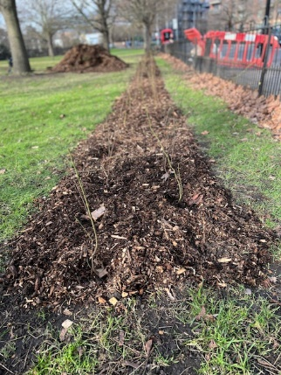

13th February – Cemetery hedge completed

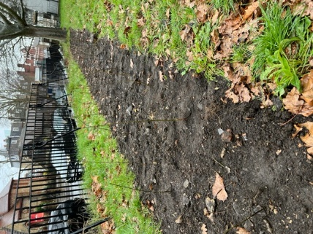

27th February – Scrub planting completed

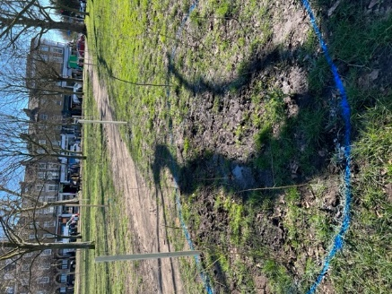

9th March – Fresh mulch had to be removed from “Friends” hedge

14th March – Definite springing to life of the 231 metre hedge – Dog Rose, Grey Willow, Spindleberry, Hawthorn and Hazel all greening up (Hazel was the slowest for us)

18th March – Decision is taken and blighted Holly is removed and counted in from the Scrub planting

26th April –Plant growth is strong. “Weeds” are appearing through the St. Mark’s mulch at this point. Gorse in the Scrub planting needs a bit of a water and weeding around base

30th April- Mulching of the Scrub planting done as far as we could

3rd May – All plantings good and all we had hoped for at this stage. Looking back, this would be a good date to re-mulch

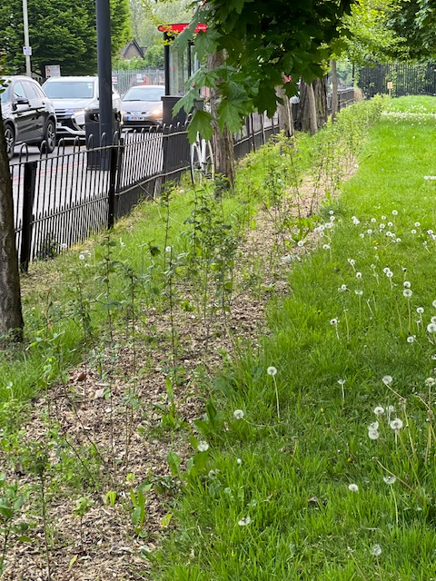

5th May – First Spindleberry of the planting blooming at The Cemetery

9th May – Some Gorse showing starting signs of lack of water or lack of “take” at The Scrub planting

9th May – Strimming done at The Cemetery and some whips get strimmed down to 2 inches. Grey Willow at St. Mark’s Planting showing stress (brown on their leaves)

12th May – Gorse showing lack of hydration at The Scrub Planting

23rd May – St. Mark’s Planting - signs of shrivelling of Hazel, Spindleberry ok, Grey Willow with brown leaf patches but hedging not planted under trees looks ok

24th May – First flowering of the Dog Rose In The Cemetery

24th May – Vandalism of the railings at The Scrub Planting

1st June – Northern section of the St. Mark’s hedge needing a good watering as although there has been rain, the hedge is covered along half of its length by interspersed trees

7th June – St. Mark’s planting looking good (apart from the Northside Section)

22nd June – Watering needed at the sites. Volunteer watering begins around this time (particularly along the Northside of The St. Mark’s Planting) but some plants have already been too badly affected

24th June – St. Mark’s planting – Hazel shrivelled, Grey Willow shrivelled, Hawthorn ok, Spindleberry ok, small hedge at St. Mark’s full of weeds

5 July –Mulching round scrub plants in The Scrub Planting done. We can see them now

15 July – Plants within the railings at the Scrub Planting are shrivelling. St. Mark’s small hedge is shrivelling, the huge lot of weeds accumulated at the base are dying. Plants in the 231m hedge are dying, all plants are yellow and shrivelling. Spindleberry is faring the best in these Climate Change conditions, followed by Hawthorn

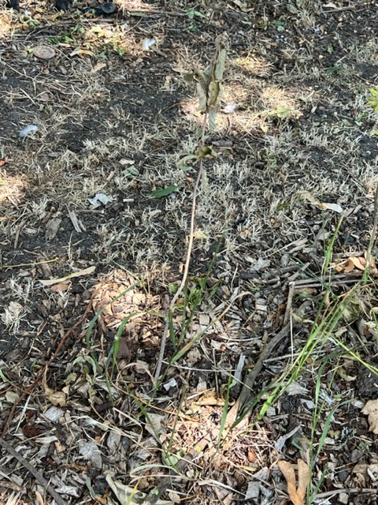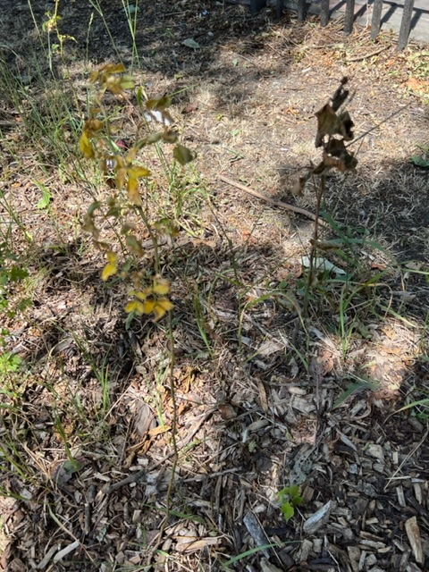

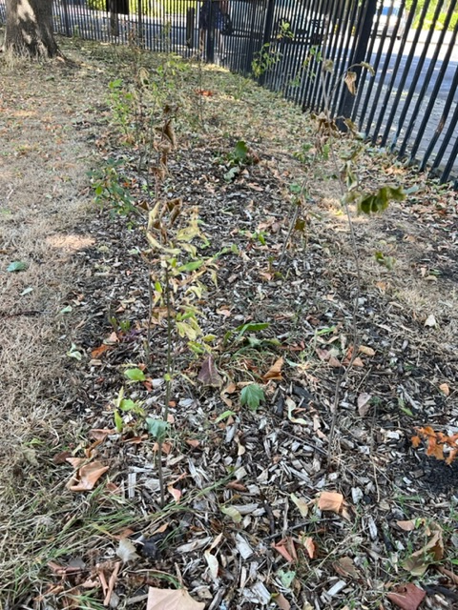

19 July – HOTTEST DAY EVER

August – Rain begins again from 9th August

21 October – the watering in the St. Mark’s hedge “just to keep the roots alive” has worked. A lot of the Hazel, which was so badly damaged, is resprouting; where the stem has died, from the base. The Grey Willow in the hedge is mainly dead. The Northern most area of the 231m hedge is largely dead and will need replanting. Fungi is growing in the mulch

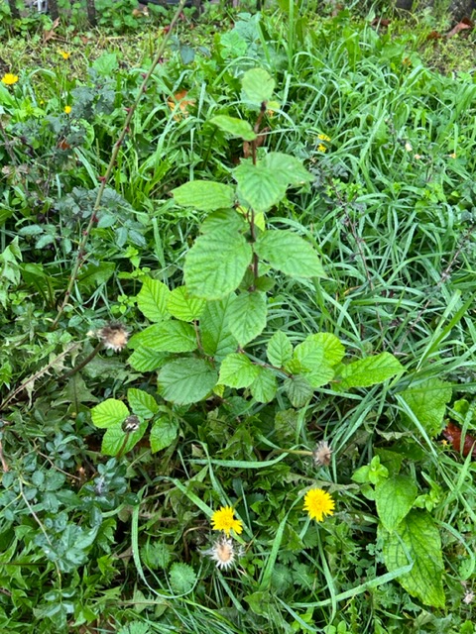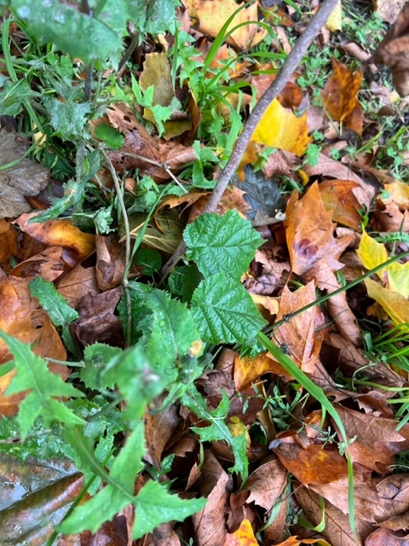

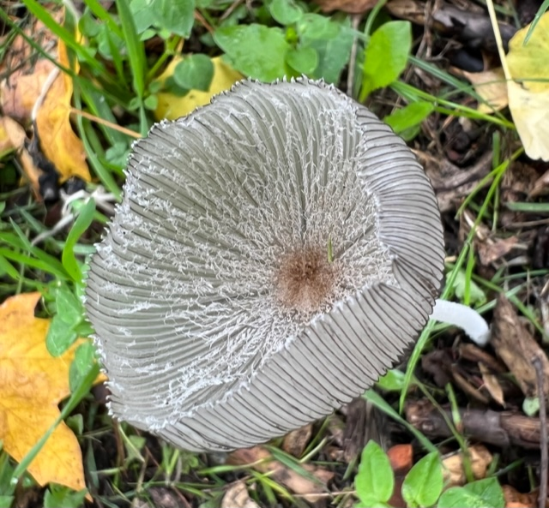

21 October – The Western area inside the railings of The Scrub planting has been badly affected and will need replanting